**Name: Mahasri M**

**CASE STUDY 2**

**Table creation:**

CREATE TABLE regions (rid int primary key, rname varchar(15));

INSERT INTO regions VALUES (1, 'India');

INSERT INTO regions VALUES (2, 'Nepal');

INSERT INTO regions VALUES (3, 'China');

INSERT INTO regions VALUES (4, 'Bhutan');

INSERT INTO regions VALUES (5, 'Russia');

SELECT * FROM regions;

CREATE TABLE customer_nodes (cid int primary key, rid int, node_id int, starting_date date , ending_date date

CONSTRAINT FK_cust_id foreign key (rid) references regions(rid));

INSERT INTO customer_nodes VALUES (101, 1, 5,'2023/01/23', '2023/02/20');

INSERT INTO customer_nodes VALUES (102, 2, 3,'2023/02/01', '2023/02/28');

INSERT INTO customer_nodes VALUES (103, 3, 2,'2023/03/01', '2023/03/20');

INSERT INTO customer_nodes VALUES (104, 4, 4,'2023/01/03', '2023/02/05');

INSERT INTO customer_nodes VALUES (105, 5, 1,'2023/01/12', '2023/02/09');

INSERT INTO customer_nodes VALUES (106, 1, 3,'2023/02/13', '2023/02/28');

INSERT INTO customer_nodes VALUES (107, 2, 5,'2023/03/12', '2023/03/19');

SELECT * FROM customer_nodes;

CREATE TABLE customer_transaction (cid int, tdate date, ttype varchar(20),tamount int,

CONSTRAINT FK_CUST_TRANS FOREIGN KEY (cid) REFERENCES customer_nodes(cid));

INSERT INTO customer_transaction VALUES (101, '2023/02/01','withdraw', 8000);

INSERT INTO customer_transaction VALUES (102, '2023/02/10','deposit', 5500);

INSERT INTO customer_transaction VALUES (103, '2023/03/13','withdraw', 4800);

INSERT INTO customer_transaction VALUES (104, '2023/02/01','withdraw', 6700);

INSERT INTO customer_transaction VALUES (105, '2023/01/29','deposit', 5550);

SELECT * FROM customer_transaction;

**1. How many unique nodes are there on the Data Bank system?**

select count(distinct node_id) unique_nodes from customer_nodes;

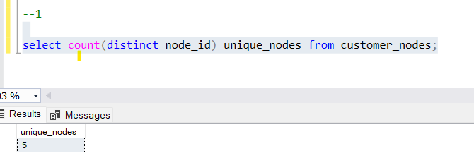

**2. What is the number of nodes per region?**

select n.rid,r.rname,

count(distinct n.node_id) unique_nodes,

count(n.node_id) number_of_nodes

from customer_nodes n

left join regions r on n.rid = r.rid

group by n.rid, r.rname

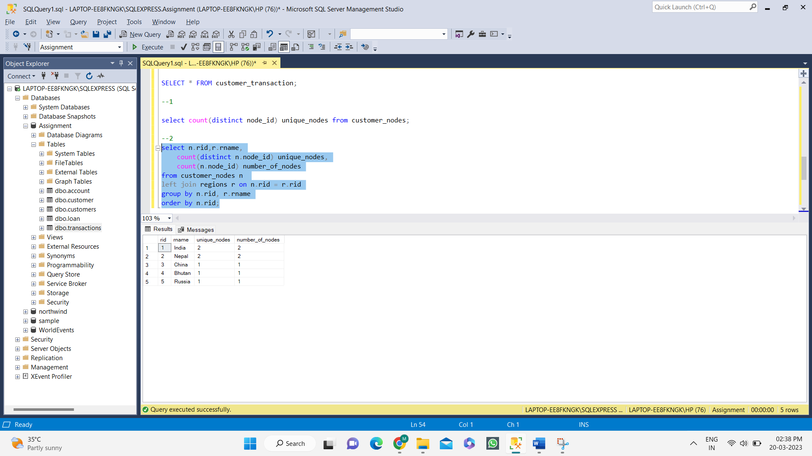order by n.rid;

**3. How many customers are allocated to each region?**

select r.rname,

count(distinct n.cid) total_customers

from customer_nodes n

left join regions r on n.rid = r.rid

group by n.rid, r.rname

order by n.rid;

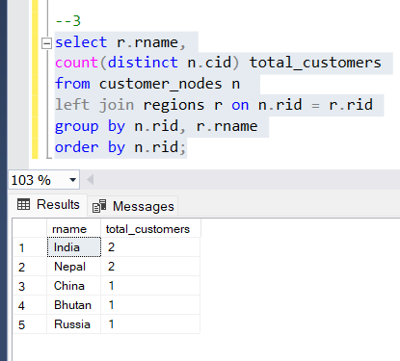

**4. How many days on average are customers reallocated to a different node?**

select AVG(DATEDIFF(D, starting_date, ending_date)) average

from customer_nodes

where ending_date != '2023/01/28';

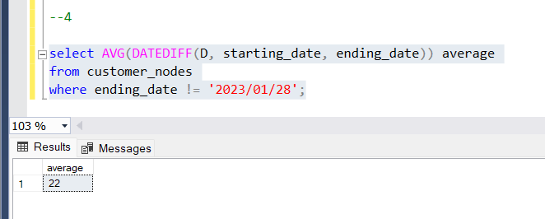

**6. What is the unique count and total amount for each transaction type?**

select ttype,

count(ttype) unique_count,

sum(tamount) total_amount

from customer_transaction

group by ttype

order by ttype;

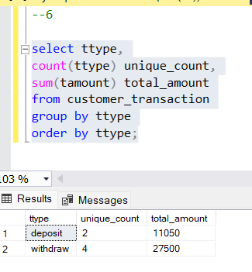

**7. What is the average total historical deposit counts and amounts for all customers?**

WITH cte_deposit AS (

SELECT cid,

COUNT(ttype) AS deposit_count,

SUM(tamount) AS deposit_amount

FROM customer_transaction

WHERE ttype = 'deposit'

GROUP BY cid)

SELECT

AVG(deposit_count) AS historical_avg_deposit_count,

AVG(deposit_amount) AS historical_avg_deposit_amount

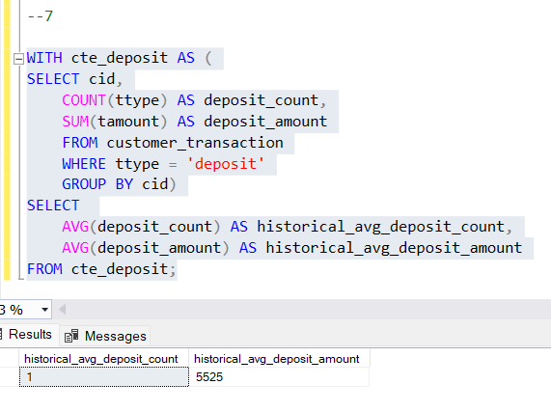FROM cte_deposit;

**8. For each month - how many Data Bank customers make more than 1 deposit and either 1 purchase or 1 withdrawal in a single month?**

select n.cid,

DATEPART(M, t.tdate) month_id,

DATENAME(M, t.tdate) month_name,

count(t.ttype) total

from customer_transaction t

left join customer_nodes n on t.cid = n.cid

left join regions r on n.rid = r.rid

group by n.cid, DATEPART(M, t.tdate), DATENAME(M, t.tdate);

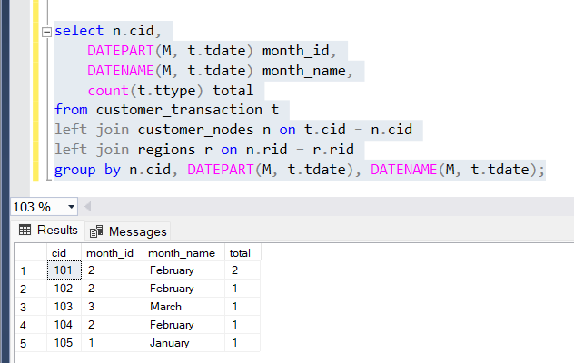

**10) What is the percentage of customers who increase their closing balance by more than 5%?**

select ROUND(100 * CAST(COUNT(cid) as float) /

(select count(*) from customer_transaction), 2) percentage_of_customers

from customer_nodes

where node_id < 5;

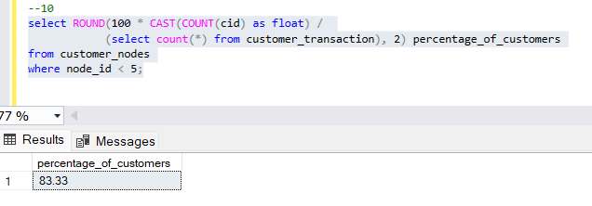

**ER DIAGRAM:**

